AODA Youth Leadership Training

(A follow-up to the Peer Helper Training held on December 12)

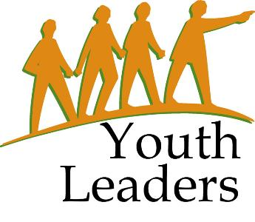
CESA #12 Conference Center
March 9, 2012

9:00 AM – 2:00 PM

Presenter: Jane Larson,
Project Outreach

Bring your youth leadership team to a day devoted to helping them learn to empower, inspire and motivate other youth to take action and reduce alcohol and drug use in their school and community. Spend time learning how to organize activities that raise awareness about alcohol and drugs, how to talk to other students about drugs and alcohol, and brainstorming/planning fun activities so that students have healthy, drug and alcohol free ways to spend their free time.

Fee is $10 per student.
There is no charge for the adult chaperone/counselor.

When registering, please note how many students
you will be bringing.

Please register by March 2, 2012

To register, go to: myquickreg.com

p

